

**BELLAMY MIDDLE SCHOOL**

**COLLEGE & CAREER**

**SPOTLIGHT**

**Getting to Know the 8th Grade Guidance Counselor ~**

**Mrs. Penny Manteria**

Mrs. Manteria grew up in Shrewsbury, MA, with her family, which included one older sister and a younger brother. She was a conscientious student who worked hard and made sure her homework was always turned in on time. Mrs. Manteria enjoyed both Math and Science, but was not a fan of Social Studies or ELA. Growing up, Mrs. Manteria loved to play sports, including football and basketball, she also a member of her high school’s cheerleading team and played softball too.

As Mrs. Manteria began to think about her future, she wanted to be an architect or maybe a dentist; but it was her dad who convinced her to go to college and study business. She graduated from Northeastern University with a degree in business and after working in the field for a while, she began to feel like her job wasn’t as meaningful as she had hoped. This would eventually lead Mrs. Manteria into the Peace Corps, where she would live and work with the women of Bolivia and help them set up small businesses.

After returning home from the Peace Corps, Mrs. Manteria decided to further her education and returned to college at the University of Massachusetts. There she would earn her graduate degree in counseling, because she knew she wanted to work with children. Mrs. Manteria loves what she does and wouldn’t want to change it, (well except the paperwork)! She likes working with parents and teachers, but especially loves her connection with the students. One of the most fulfilling aspects of her job is watching her students succeed and achieve their goals academically, socially, and emotionally.

In her spare time, Mrs. Manteria likes to read, go to the gym, kickboxing, and of course spending time with her children and family!

College Spotlight

**Northeastern University**

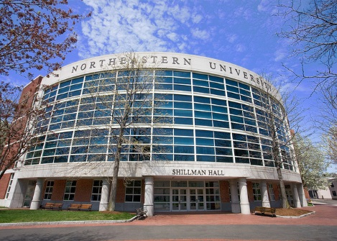

* Founded in 1898, Northeastern is a global, experiential, research university built on a tradition of engagement with the world, creating a distinctive approach to education and research.
* Admission to Northeastern’s undergraduate program is highly competitive. Our goal is to build a diverse community of intellectually curious, mature, and highly motivated students who are a good match for our distinctive educational experience.
* Northeastern's tradition of global engagement empowers our undergraduates to chart their own academic path, through more than 90 majors and concentrations and global experiential learning opportunities in 92 countries.
* Northeastern is home to a vibrant and competitive athletic program, including 18 varsity sports at the Division I level, 43 club sports, and 32 intramural sports.
* First-year students live in one of our popular [Living Learning Communities](http://www.northeastern.edu/reslife/livinglearning/) (LLCs), which connects students of similar academic and personal interests.
* A Northeastern education is student-focused. With the support of a team of advisers, you choose your path—a four- or five-year program, the number of co-ops and study abroad terms you’d like to complete, and how to best maximize your time here.

**University of Massachusetts**

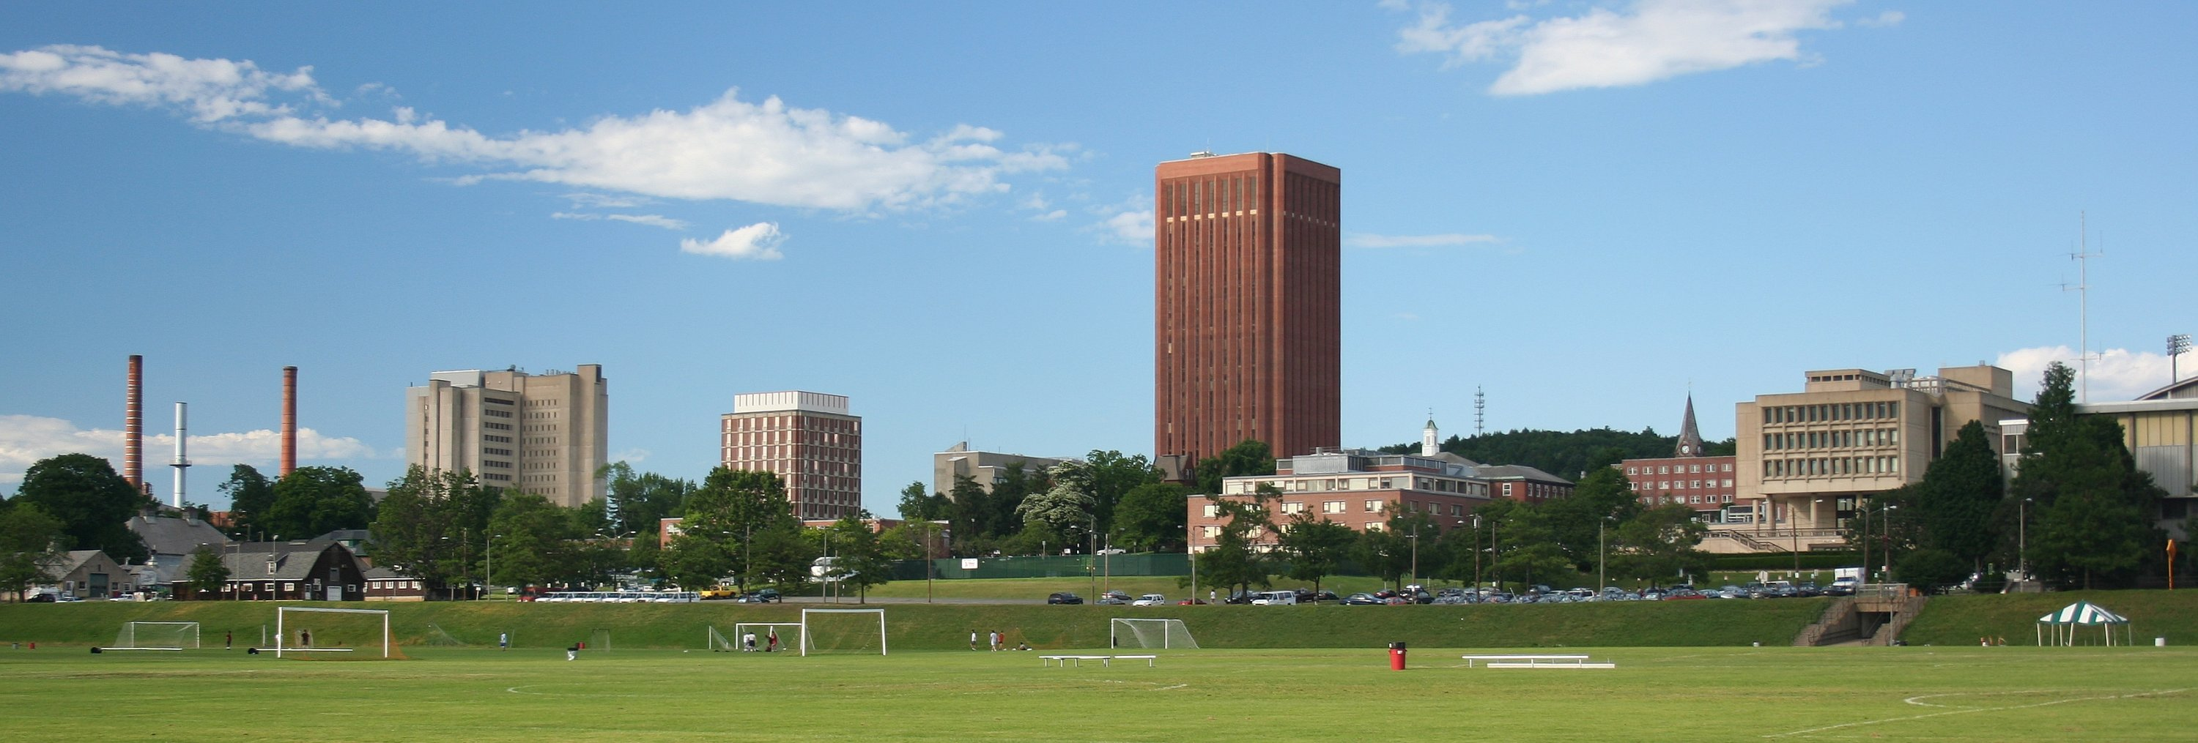

* The University of Massachusetts is the Commonwealth’s only public research university system. It consists of five campuses in Amherst, Boston, Dartmouth, Lowell and UMass Medical School in Worcester. The University also has a satellite in Springfield and a School of Law in Dartmouth.
* UMass is currently ranked as the No. 1 public university in New England and is among the world’s top 100 universities, according to Times Higher Education World Rankings.
* The University of Massachusetts has been providing high-quality educational opportunities for more than 150 years. It was established in 1863 as the Massachusetts Agricultural College, located in Amherst.
* Whether you like to watch sports or participate in them, UMass Amherst is a great school for athletics. Our varsity athletes compete in Division I, (football is in Division 1A) the NCAA’s highest level of intercollegiate athletic competition, and in the prestigious Atlantic 10 Conference.
* There is a huge array of scholarships available to students. They may be available from UMass Amherst itself, your state, your town, organizations that you volunteer with, and many other sources. You just have to seek them out.